# **Statements in Java**

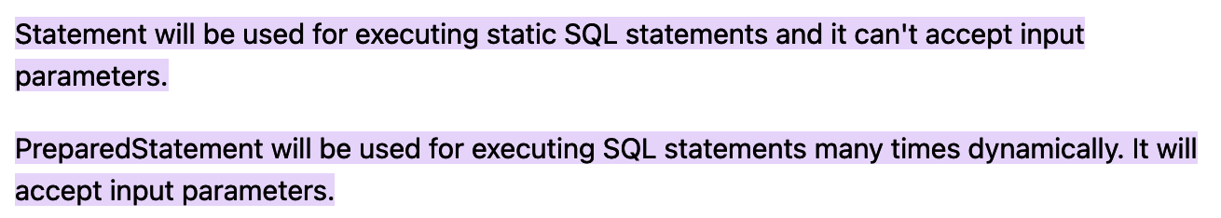

# **References**

[Types of Statements in JDBC - GeeksforGeeks](https://www.geeksforgeeks.org/types-of-statements-in-jdbc/)